**Overall Objective:**

* Use collaboration to plan a video outline and the necessary components
* Create individual blog posts on our fastpages describing our use of collaboration
* Show this document as well as blog post in individual videos to show use of collaboration in video grading

**Video Outline:**

* Use either [Loom](https://www.loom.com/download?utm_term=loom%20video_e&utm_campaign=US_GS_Brand_Phrase_Exact&utm_source=adwords&utm_medium=ppc&utm_content=&hsa_acc=4481576800&hsa_cam=18085027158&hsa_grp=139903503803&hsa_ad=617138873409&hsa_src=g&hsa_tgt=aud-1508969361551:kwd-347639226674&hsa_kw=loom%20video&hsa_mt=e&hsa_net=adwords&hsa_ver=3&gclid=CjwKCAjw4JWZBhApEiwAtJUN0JTkaBfJxQt6qlFE6BtzMpElHnglsqwVBbk2rJvbDfxDtMkfpCrXLhoCuRgQAvD_BwE) or [Screencastify](https://www.screencastify.com/products/screen-recorder?gclid=CjwKCAjw4JWZBhApEiwAtJUN0GR2A5phzIDuWvSqOc1YMefw29MMrrNpVn1NrwDj6nampoGAcsHhsxoC8IgQAvD_BwE) to screen record a video of making changes.
* Use [WeVideo](https://www.wevideo.com/) to create video

1. Introduction- Say name and describe purpose/function of the video and project
2. Show both servers running on individual machine simultaneously (Pull up tabs of flask website and locally run repository page).
3. Make an edit on each server in VSCode and show reflected change using Browser.
   1. show the change on VScode for the flask webpage, then commit, then show immediate result on flask website which is run locally
   2. Show a change on VScode for your fastpage repository, then SAVE by clicking file->save (don’t commit yet= this makes changes final and uploads to actual blog not local one) and show immediate change on the LOCAL webpage. The local page should have “localhost” like this in the URL: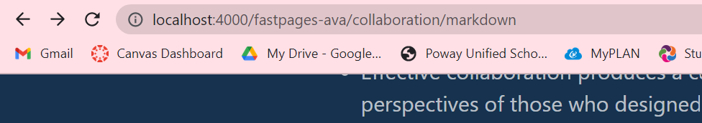

This webpage should show the change you made, but NOT on the actual fastpage (MAYBE SHOW HOW CHANGE IS NOT FINAL ON ACTUAL BLOG SITE).

1. Show making a permanent change (THIS IS WHEN YOU Commit, Sync) on VSCode.
2. Show GitHub change list and show delta of change on GitHub Web Page (Go to actions and show the final change that has been committed).
3. On Fastpages show initiated Action from change (Pull up ACTUAL blog site for your fastpage and show final change has been made).
4. On Fastpages show GitHub pages reflected change using Browser.
5. Go to Fastpage and show the blog about collaborating. Click the link to this document and EXPLAIN USE OF COLLABORATION. ← This should help us earn 2.7+ on grading review.
6. Say outro (thank you for listening to my video)

**Week Plan, Grading System, and Requirements**

* <https://nighthawkcoders.github.io/APCSP//points/4>

**Advice: Tips and Tricks:**

* Record MULTIPLE individual videos of each change
* Make a new project and video on WeVideo
* Edit these videos together using transitions from WeVideo (there should be available transitions you are able to click)
* Add background music
* Add titles, arrows, text, and voiceovers to explain and get points across
* Get feedback from group members on how to improve
* Add fun visuals to excite viewers?
* **Download this doc as a docx**